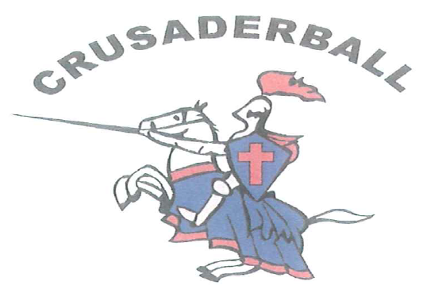

On behalf of the Crusaderball Youth Baseball and Softball programs, I would like to thank you in advance for your consideration in supporting our program.

Crusaderball is a Christ centered youth baseball and softball program that has been established and maintained by volunteers and is funded completely by participation and donation. We offer programs for boys and girls from ages 5-14 years ranging from t-ball to competitive baseball and softball. The coaches, managers, and board of directors consist of dedicated volunteers whose goal is to develop kids not only in athletics but in their relationship with Christ. Our program ministers to today’s youth while striving to improve skills, sportsmanship, teamwork, and enjoyment of athletics. Our programs provide support that meets the needs of players on and off the field.

Crusaderball is organized exclusively for one or more of the purposes as specified in Section 501c3 of the Internal Revenue Code. Sponsorship / Donation funds are properly recorded and monitored to insure Crusaderball conforms to Federal Tax laws.

With the help of donations from supporters such as you, we will continue to see improvements in programs and facilities that provide the range of basic skills as well as programs which offer opportunities of those who wish to advance to the highest levels attainable. Thanks again for your generous support of our efforts to make Crusaderball successful.

**If you would like to help support our program there are multiple ways to do so.**

**#1 Platinum Sponsorship $550.** Platinum **S**ponsorship’s will be used for team uniforms where needed. In 2023 there may be multiple sponsors listed on a given team. 2023 Platinum sponsors will be recognized with “Thank You” signage throughout Ramsey Fields.

**#2 Gold Sponsorship $250.** Gold Sponsorships will be used for team equipment and general additional supplies. 2023 Gold sponsors will be recognized with “Thank You” signage throughout Ramsey Fields.

**#3 Cash or Material Donations.** Cash donations become part of the Crusaderball general fund and are allocated to program needs or projects. Material donations will be applied to projects as needed.

**#4 Outfield Sign Purchase.** Sign purchase is $500.00 initial cost, and $250.00 yearly renewal. Signs can be made with any business names and logos, pending approval by Crusaderball director and Modesto Christian School.

**Sincerely, _______________________________________**

**2023 Crusaderball Coach.**

**Sincerely, _______________________________________**

**2023 Crusaderball Board Member.**